課程名稱：正向教養 – 溫和表達 + 堅定管教
專為華人移民家庭提供的家長學習成長課程
課程日期：每月一期，每週五中午12:00 – 下午1:30 上課
課程費用：一期四堂課，個人價 $100.00、父母共學價 $150.00
課程地點：爾灣 （405公路與機場旁）2101 Business Center Drive, Suite 150, Irvine, CA 91612
主辦機構：OMID多元文化身心發展學會
主辦講師：丁彩齡 MS, AMFT # 98242
心理諮詢碩士  美國正向教養協會註冊家長講師  婚姻與家庭實習心理諮詢師

報名條件：家有學齡孩子 (六到十八歲) ，願意學習與分享的用心父母
報名方式：提供報名資料，電郵至 TFraher@Omidinstitute.org 或發短信到 (949) 988-0259

報名資料： 1. 學員姓名 / 聯絡電話郵箱 / 報名參加的課程月份
2. 孩子年齡 / 性別 / 就讀年級
3. 對課程具體期望（三項）
報名流程： 1. 發送郵件或短信報名
2. 如有名額，您會收到付費通知
3. 如當期名額已滿，我們會依據報名次序，將您放在候補名單或安派下一期上課

正向教養 (Positive Discipline) 的核心理念是什麼？
- 不懲罰、不驕縱
- 溫柔和堅定並行
- 先連接, 再糾正
- 感覺好做得好
- 錯誤是最好的學習機會
- 每個人都不一樣
- 贏得孩子而不是贏了孩子
- 每天進步一點點

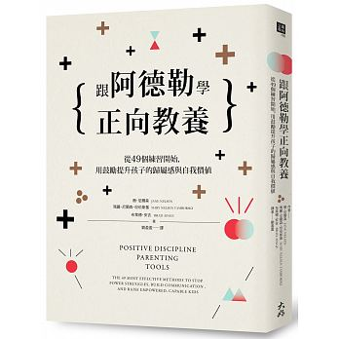
正向教養家長課程學什麼？
✔ 學習如何幫助孩子自我管理
✔ 學習如何懂孩子
✔ 學習如何面對情緒
✔ 體驗式互動學習
✔ 接納不完美的勇氣

Class Title: Positive Discipline : Wise Parents, Motivated Kids!
Parenting Class tailored for Mandarin-speaking immigrant families
Class Time: Monthly sessions, every Friday 12:00noon – 1:30pm
Class Cost: Four meetings each month. $100 for individual, $150 for couple.
Location: 2101 Business Center Drive, Suite 150, Irvine, CA 92612
OMID Multicultural Institute for Development
Instructor: Tsai-ling Fraher, MS, Associate Marriage and Family Therapist, AMFT# 98242
Certified Positive Disciplined Parent Teacher

- Who should enroll?
Mandarin-speaking parents with school-aged children who would like to learn new
and effective ways of communicating and disciplining their children.
- How to enroll?
Provide following information to TFraher@Omidinstitute.org via e-mail
or text/call (949) 988-0259
- What information is needed for enrollment?
1. Name of participant/contact phone and e-mail/month interested in attending
2. Child’s age/gender/grade
3. Specific learning expectations for the class (provide 3)
- What is the enrollment process?
1. Provide information via e-mail or text.
2. Participants will be notified via e-mail or text regarding which sessions they are
enrolled in and how to make a payment to reserve their spots.

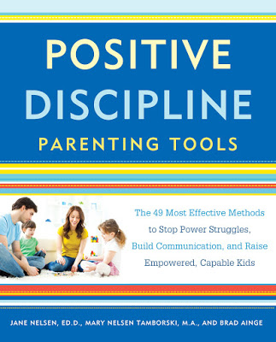
What are the core beliefs of Positive Discipline?

- Not punishing, not spoiling
- Kind and firm
- Connect before correct
- Good feelings lead to good behaviors
- Mistakes are the best chance for learning
- Each person is unique
- Create win-win situation with children
- Take notice of small progress everyday

What do I learn at Positive Discipline classes?
✔ Learn how to teach my child self-discipline
✔ Learn how to understand my child
✔ Learn how to work with emotions
✔ Experiential and interactive learning
✔ Learn the courage to accept imperfections

